

KINDLY SPONSORED BY

**CONCEPT TAVERNS / THE NORTHERN SNOOKER CENTRE**

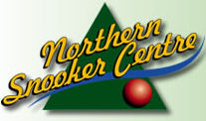 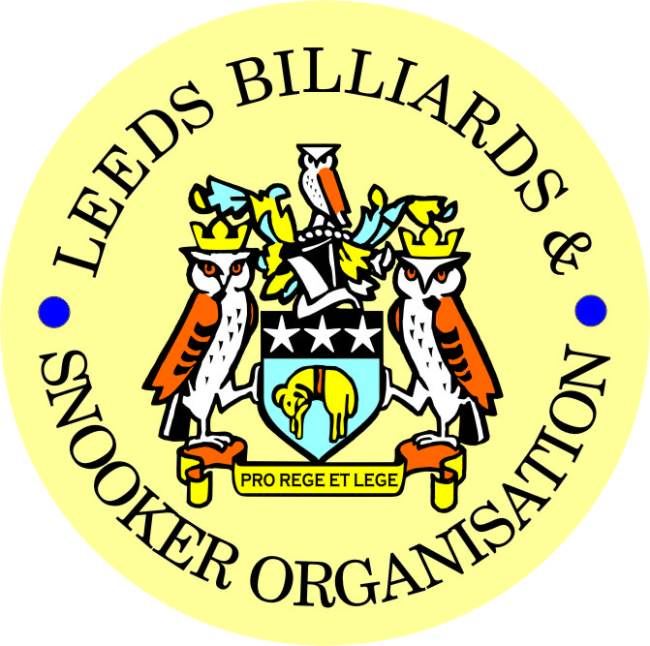 

|  |
| --- |
| ***FINAL – 2022/23 LEEDS CITY SNOOKER CHAMPIONSHIP***  ***& PRIZE PRESENTATION EVENING***  ***WEDNESDAY 7th JUNE 2023***  ***NORTHERN SNOOKER CENTRE*** |

|  |
| --- |
| **2022/23 LEEDS CITY SNOOKER CHAMPIONSHIPS**  **SINGLES FINAL - BEST OF 7 FRAMES**  **DANIEL WOMERSLEY (4) v STEPHEN BROADHEAD (1)**  ***FOLLOWED BY-***   * **PRESENTATION OF THE SINGLES TROPHY & INDIVIDUAL AWARDS-** * **PRESENTATION OF ALL OTHER - 2022/23 LCC – Annual trophies and individual awards** |

|  |  |
| --- | --- |
| **\*\* 2022/23 LEEDS CITY CHAMPIONSHIPS \*\*** | |
| **JUNIORS - UNDER 16’s SNOOKER:**  **Trophy - Presented by ADT Flexibles (UK) Ltd.** | |
| WINNER: **VLADISLAV GRADINARI** | RUNNER-UP: **OLIVER HUDSON** |
|  | |
| **JUNIORS - UNDER 18’s SNOOKER:**  **“The Keith Weston Memorial Trophy”- Presented by ADT Flexibles (UK) Ltd.** | |
| WINNER: **LIAM PULLEN** | RUNNER-UP: **VLADISLAV GRADINARI** |
|  | |
| **JUNIOR HIGH BREAK: - “The Paul Hunter Memorial Trophy” – LIAM PULLEN (117)** | |

|  |  |
| --- | --- |
| **INDIVIDUAL SNOOKER:** | |
| WINNER: **DANIEL WOMERSLEY** | RUNNER-UP: **STEPHEN BROADHEAD** |
| SEMI-FINAL: **BARRY FRANKLAND** | SEMI-FINAL: **LEWIS GILLEN** |
| **PAIRS SNOOKER:**  **Trophy - Presented by ADT Flexibles (UK) Ltd.** | |
| WINNERS: **MARK BALL / SCOTT RAPER** | RUNNERS-UP: **D. HUGHES / M. GAUGHAN** |
| SEMI-FINAL: **G. CASSIDY / R. BINNS** | SEMI-FINAL: **DANNY DEAN / DAMIEN GALE** |
| **TEAM SNOOKER – “The Jim Fowler’s Trophy”:** | |
| WINNERS: **BELLE ISLE WMC** | RUNNERS-UP: **FARSLEY CONS** |

|  |
| --- |
| ***2022 / 2023 - *PRIZE PRESENTATION EVENING\****  ***WEDNESDAY 12th JULY 2023***  ***SOUTH LEEDS CONSERVATIVE CLUB*** |

|  |  |
| --- | --- |
| **SNOOKER - “Veterans Trophy” – 50+**  **“The Rodney Sims Memorial Trophy”**  **Presented by the LBSO** | **REFEREES:**  **Officiated in 2022-23 LBSO Competitions:** |
| **WINNER: STEVE PARLOUR** | **ANDY KITSON** |
| **RUNNER-UP: PAUL GRIMES** | **KENNY SYMONS** |
|  | **MICHAEL DAVENPORT** |
| **PLATE WINNER: DARREN EARLY** |  |
| **PLATE RUNNER-UP: KARL BRIGGS** |  |

|  |  |  |
| --- | --- | --- |
| **\*\* LBSO - SNOOKER LEAGUES \*\*** | | |
| **Div:** | **CUP TITLE / WINNERS:** | **RUNNERS-UP:** |
| **Div A** | **The Yorkshire Evening News Shield:**  **SWARCLIFFE WMC ‘A’** | **BELLE ISLE WMC ‘B’** |
| **Div B** | **The J. McDonnell / J. Williamson Trophy:**  **TINSHILL & COOKRIDGE ‘C’** | **BRAMLEY VILLAGERS ‘A’** |
| **Div C** | **The John Dunning Trophy:**  **HAREHILLS LABOUR ‘A’** | **CROSSGATES WMC ‘A’** |
| **Div D** | **The J. H. Lunn Cup:**  **BELLE ISLE WMC ‘D’** | **SWARCLIFFE WMC ‘C’** |
| **Div E** | **The Peter Nelson Trophy:**  **MORLEY CONS ‘B’** | **PUDSEY LIBERALS ‘B’** |
| **Div F** | **The Peter Hawkyard Memorial Trophy:**  **MENSTONE BAR & SNOOKER CLUB ‘A’** | **CHAPEL ALLERTON ‘A’** |

|  |  |
| --- | --- |
| **“CHAMPION of CHAMPIONS”**  **“The Jim Williamson Memorial Trophy”**  **Presented by the Northern Snooker Centre** | WINNERS: **TINSHILL & COOKRIDGE ‘C’**  **(DIVISION B WINNERS)** |

|  |  |  |
| --- | --- | --- |
| **LBSO - LEAGUE & COMPETITIONS – SNOOKER HIGHEST BREAKS**  **HIGHEST BREAK TROPHY**  **Presented by ADT Flexibles (UK) Ltd. in 2019** | | |
| **Break** | **League / Competition** | **Player (Team)** |
| **136 + (113 & 99)** | **LEN LEE INV / (DIVISION F)** | **GYLES BEHBOOD** |
| 117 | LCC JUNIOR (QUALIFIERS) | LIAM PULLEN |
| 108 | COMPETITION | DANIEL WORMESLEY |
| 101 | LCC TEAM COMPETITION | RICHARD BINNS |
| 94 | LEAGUE DIVISION A | DANIEL BOYES |
| 93 | LEAGUE DIVISION F | TOM HARRIS |
| 91 | LEAGUE DIVISION A | TOMMY DOHERTY |
| 89 | SYKES CUP | MARK BALL |

|  |  |
| --- | --- |
| LEN LEE INVITATION SNOOKER – (Scratch):  **“THE LEN LEE TROPHY”**  **Trophy presented by**  **ADT Flexibles (UK) Ltd**  **for 2020** | WINNER: **GYLES BEHBOOD (MENSTONE SC)**  RUNNER-UP: **RICHARD BINNS (BELLE ISLE WMC)** |

|  |  |
| --- | --- |
| **SNOOKER – SYKES CUP - Individual Handicap.**  **The “GEORGE SYKES CUP”** | |
| WINNER: **ROY CORBETT**  **(HARHILLS WMC)** | RUNNER-UP**: VINNY PARKIN**  **(MIDDLETON CONS)** |
| SEMI-FINAL: **ADY AVEYARD**  **(ROTHWELL WMC)** | SEMI FINAL: **GRAHAM MARSDEN**  **(MIDDLETON CONS)** |

|  |  |
| --- | --- |
| **SNOOKER – LEN LEE PAIRS - Pairs Handicap.**  **The “LEN LEE CUP”** | |
| WINNERS: **S. PATTINSON & J. SMITH**  **(TINSHILL & COOKRIDGE)** | RUNNERS-UP: **ADY AVEYARD & IAN RAYNER**  **(ROTHWELL WMC)** |
| SEMI-FINAL- **J. HOWLETT & N. TURNER**  **(BARNBOW SOCIAL)** | SEMI-FINAL: **S. STEVENS & G. GODFREE**  **(NORTHERN S. C.)** |

|  |  |
| --- | --- |
| **SNOOKER - 3 MAN TEAM KNOCK OUT – Handicap.**  **The “Leeds & District Billiards League Snooker Cup”** | |
| WINNERS: **BRAMLEY BAND** | RUNNERS-UP- **GARFORTH WMC ‘A’** |
| SEMI-FINAL: **SOUTH LEEDS CONS** | SEMI FINAL:  **GARFORTH WMC ‘D’** |

|  |  |
| --- | --- |
| **\*\* STAN BROOKE MEMORIAL COMPETITIONS \*\***  **(AGGREGATE SCORES – 3/4 FRAMES)** | |
| **INDIVIDUAL SNOOKER – 3 FRAMES:** | |
| WINNER: **CHRIS INESON**  **(CROSSGATES WMC)** | RUNNER-UP**: PAUL DAVIES**  **(HAREHILLS LIBERALS)** |
| SEMI-FINAL: **KARL HEMSLEY**  **(CROSSGATES WMC)** | SEMI FINAL: **ROY CORBETT**  **(HAREHILLS WMC)** |
| **PAIRS SNOOKER – 3 FRAMES:** | |
| WINNERS: **A.TOLLERFIELD& DANIEL BOYES**  **(NORTHERN SC)** | RUNNER-UP:  **T. DOHERTY & J. DOHERTY**  **(DENISON HALL)** |
| SEMI-FINAL: **D. FRENCH & G. HARTLEY**  **(CROSSGATES REC. HALL)** | SEMI-FINAL: **BILLY ADAMS & ALAN BRIGGS**  **(ROTHWELL WMC)** |
| **TEAM SNOOKER – 4 FRAMES:** | |
| WINNERS: **GARFORTH WMC** | RUNNERS-UP: **ROWLAND ROAD** |
| SEMI-FINAL: **BEECHWOOD WMC** | SEMI-FINAL: **SWILLINGTON MINERS WELF.** |

|  |  |
| --- | --- |
| **The “WINDSOR TROPHY” – 4 Man Team Handicap**  **Presented by ADT Flexibles (UK) Ltd.** | |
| WINNERS: **BELLE ISLE WMC** | RUNNERS-UP:  **FARSLEY CONS** |
| SEMI-FINAL: **CHAPEL ALLERTON** | SEMI FINAL: **PUDSEY LIBERALS** |

***CONGRATULATIONS!***

***TO ALL PRIZE WINNERS FOR 2022-23***

**The LBSO would like to thank-:**

1. **Concept Taverns / the Northern Snooker Centre for staging the final of the 2022/23 Leeds City Snooker Singles Championship and the 1st presentation of all 2022/23 Leeds City Champions**

**on 7th June this year,**

**and also**

1. **South Leeds Conservative Club for staging tonight’s 2nd presentation of awards for the 2022/23 season.**

|  |
| --- |
| Presented By-  C:\Users\user\Pictures\Miscellaneous\LBSO Logo.jpg  **CURRENT LBSO COMMITTEE MEMBERS**  PRESIDENT – CHRIS WILLIAMSON  CHAIRMAN – ANDY TAFFINDER  VICE CHAIRMAN –  LEAGUE SECRETARY – PAUL GRIMES  COMPETITION SECRETARIES – MARK BALL & PAUL MARLOW  GENERAL SECRETARY / TREASURER – BOB PATTERSON  **A DATE FOR YOUR DIARY:**  **\*\*13th SEPTEMBER 2023\*\***  **START OF THE 2023/24 LEAGUE SEASON** |

**Kindly Sponsored by the**

**CONCEPT TAVERNS / ‘NORTHERN SNOOKER CENTRE’**

  